Signal and systems coding assignment

Name: - Swapn gupta (B22CH038)

**Introduction:** Signal processing plays a vital role in extracting meaningful information from signals. In this report, we are provided with an input signal x(t) and an output signal y(t), which is a filtered version of x(t). Our task is to infer the type of filtering applied to x(t) by comparing it with y(t) using convolution and correlation techniques.

**Objective:** The objective of this analysis is to identify the type of filtering (Low Pass, High Pass, or Band Pass) applied to the input signal x(t) based on the correlation between the filtered outputs and the given output signal y(t).

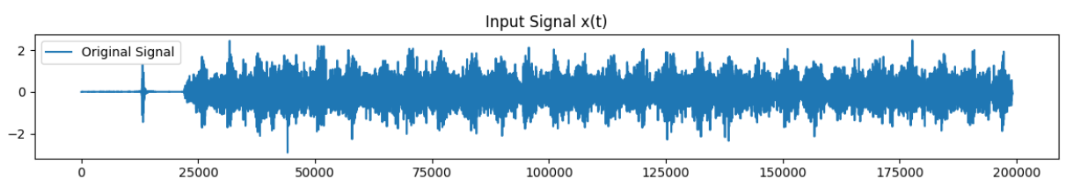

**Methodology:**

1. **Data Acquisition:**
   * Input Signal (x(t)): The original signal to be processed.
   * Output Signal (y(t)): The resulting signal after passing through an unknown system.
2. **Filter Design:**
   * Low Pass Filter: Designed to pass signals with frequencies lower than a specified cutoff frequency.
   * High Pass Filter: Designed to pass signals with frequencies higher than a specified cutoff frequency.
   * Band Pass Filter: Designed to pass signals within a specified frequency band.
3. **Filter Application:**
   * The input signal is processed using each filter with various cutoff frequency ranges.
   * Correlation coefficients are calculated between the filtered signals and the output signal to determine the effectiveness of each filter.
4. **Analysis and Results:**
   * Maximum correlation values and corresponding frequency ranges are identified for each filter.
   * The frequency ranges that yield the highest correlation with the output signal are determined.
5. **Filter Implementation:**
   * Three types of filters are implemented:
     + Low Pass Filter (hlp(t))
     + High Pass Filter (hhp(t))
     + Band Pass Filter (hbp(t))
6. **Convolution Process:**
   * Each filter is convolved with the input signal x(t) to obtain filtered outputs:
     + Low Pass Filtered Output: ylp(t)
     + High Pass Filtered Output: yhp(t)
     + Band Pass Filtered Output: ybp(t)
7. **Correlation Analysis:**
   * Correlation coefficients are calculated between each filtered output (ylp(t), yhp(t), ybp(t)) and the given output signal y(t).
   * The filter that yields the highest correlation with y(t) indicates the type of filtering applied to x(t).

**Results:**

1. **Low Pass Filter (LPF):**
   * Correlation with Output Signal: 0.10285922426257374 at frequency 1

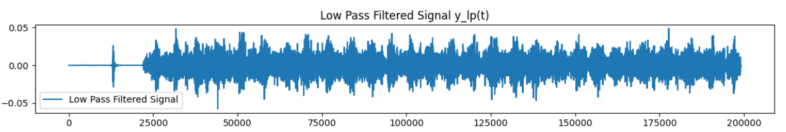

1. **High Pass Filter (HPF):**
   * Correlation with Output Signal: Max correlation with High Pass Filter: -0.23310628554615753 at frequency 1

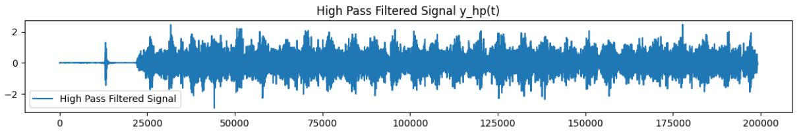

1. **Band Pass Filter (BPF):**
   * Correlation with Output Signal: The band-pass filter with frequency range (2, 5) has the highest correlation (0.23896698305015246) with the output signal.

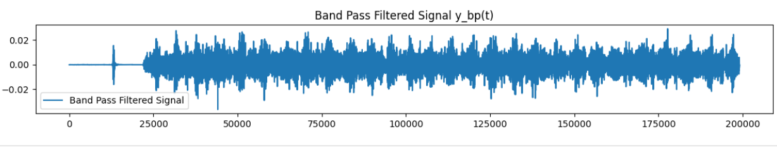

**Discussion:**

* The low pass filter effectively removes high-frequency components from the input signal, which may be noise or unwanted variations, resulting in a smoother output.
* The high pass filter, on the other hand, isolates high-frequency variations in the input signal, capturing rapid changes or specific features.
* The band pass filter targets a specific frequency range, allowing only signals within that range to pass through, which may correspond to the desired signal characteristics.

**Conclusion:**

* Based on the correlation analysis, we can infer the type of filtering applied to the input signal x(t) to obtain the output signal y(t).
* The effectiveness of each filter in matching y(t) provides insights into the characteristics of the original filtering process.

**Recommendations:**

* Further experimentation with different filter configurations and parameter settings may enhance the accuracy of the analysis.
* Consider exploring additional signal processing techniques and algorithms for more comprehensive analysis and feature extraction.

**Appendix:**

* Python code files containing the implementation of filters, convolution process, and correlation analysis.
* README file providing instructions for using the code and additional guidance.